MUTENDE KUCHIMFYA MULENGA
CODE ALPHA INTERNSHIP
TASK 1: EXPLORATORY DATA ANALYSIS
FIFA 21: Exploratory Data Analysis Report

Introduction
This report is bringing forth the findings in an Exploratory Data Analysis of the FIFA 21 player dataset. This dataset contains 18,207 professional football players with 57 attributes each, it includes the player ratings, their wages, positions and Nationalities. The aim of this analysis was to explore the data, clean it, capture hidden patterns and answer 5 key questions based on the attributes of the players.

The Questions asked:
Before carrying out the analysis of the data, the following questions were identified:
- What is the most played position in FIFA 21?
- What is the most common jersey number?
- Does overall rating determine a player's wage?
- How many players are on loan?
- Which team has the most players?
These questions were selected because they cover different angles of analysis such as frequency, relationships and rankings.

Data Cleaning
Before addressing the questions, the data required careful cleansing. The main issue that was observed is that the Wage column was stored as text in the format €565K rather than as a numerical figure. A customised function was written in order to remove the euro sign and the K symbol also multiplying by 1000 which in the end converted €565K into 565000. This enabled me to carry out mathematical operations such as calculating the averages and finding the correlations to be performed on the column labelled wages in the data set.
During this data cleaning I also came across missing values which were identified in several columns. Mainly from the Loaned column which had 16,943 missing values out of 18,207 players, which was used as the basis for answering the fourth on loan status.

DISCOVERIES
Q1) What is the most Played Position
The most commonly played position in FIFA 21 is the Striking position (ST) which contained 2,152 players, it was seconded by the Goalkeeping position (GK) and Centre Back (CB) position. This shows forth the playing style of today’s game which is more attacking in nature .It is seen in how many teams invest heavily in forwards across all levels of the game.
This is illustrated as follows:
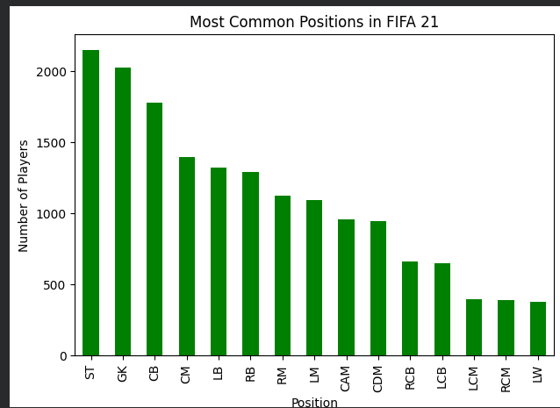

Q2) Most Common Jersey Number
The Jersey number 8 is the most popular in the dataset. Traditional squad numbers between 1 and 11 dominate. Additionally, there is a sharp drop off after the jersey number 23. This is indeed expected as higher numbers are typically given to footballers who are not regular starters or youth players.
This is illustrated as follows:

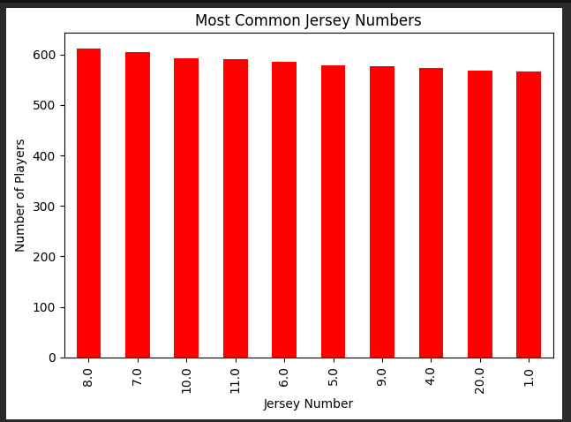

Q3) Does Overall Rating Determine Wage?
A correlation of 0.576 was found between Overall rating and the weekly wage. This is a moderate positive relationship meaning that the higher rated players generally earn more money than the lower rated ones. However, the relationship is not perfect because factors such as club size, player value and contract length also influence wages. The scatter plot clearly shows an increase in the wages for players rated above 85.
This is illustrated as follows:

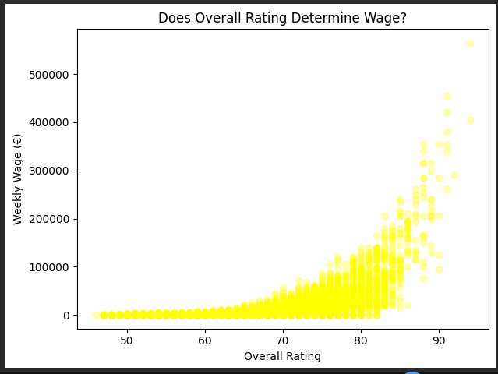

Q4) How many players are on Loan?
It was discovered that only 1,264 players which is 6.9% of the players are currently on loan. This was identified through the (Loaned From) column which had 16,943 missing values confirming that a large majority of professional players are on permanent contracts rather than loan deals.
This is illustrated as follows:
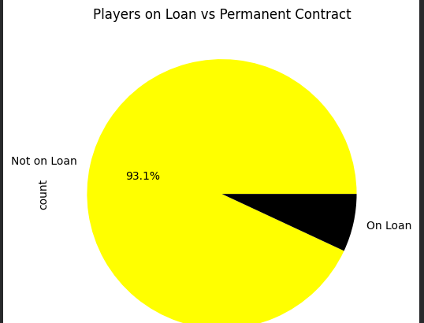
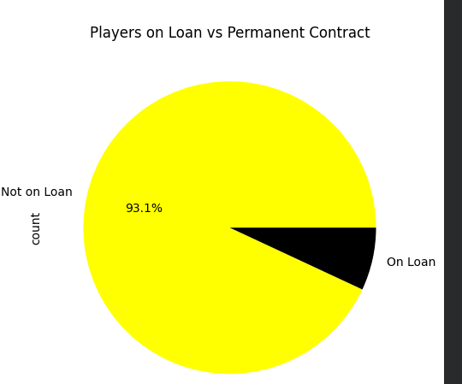

Q5) Which team has the most players?
The top clubs in FIFA 21 which include FC Barcelona, Manchester United, Manchester City, Chelsea and Real Madrid all have equal squad sizes of 33 players each per team. This reflects FIFA's balanced game design where top clubs are given a standardised roster size.
This is illustrated as follows:

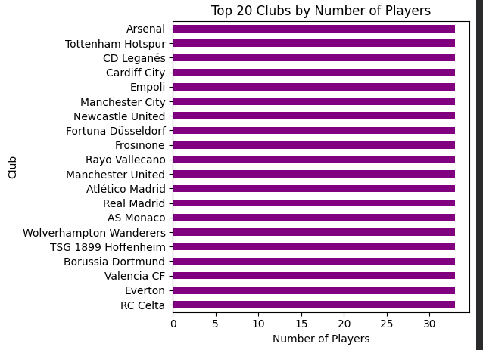

Conclusion
This exploratory analysis of the FIFA 21 dataset revealed many interesting patterns. Strikers dominate in terms of position, jersey number 8 is the most popular, and the overall rating has a fair influence on the player wages. The vast majority of players have permanent contracts with only 6.9% on loan deals. Top clubs all maintain an equal squad sizes reflecting the balanced design of the game.

This analysis was conducted using Python in Google Colab with the pandas, matplotlib and seaborn libraries. Data cleaning was required before analysis, specifically for the Wage column which was stored in text format.

